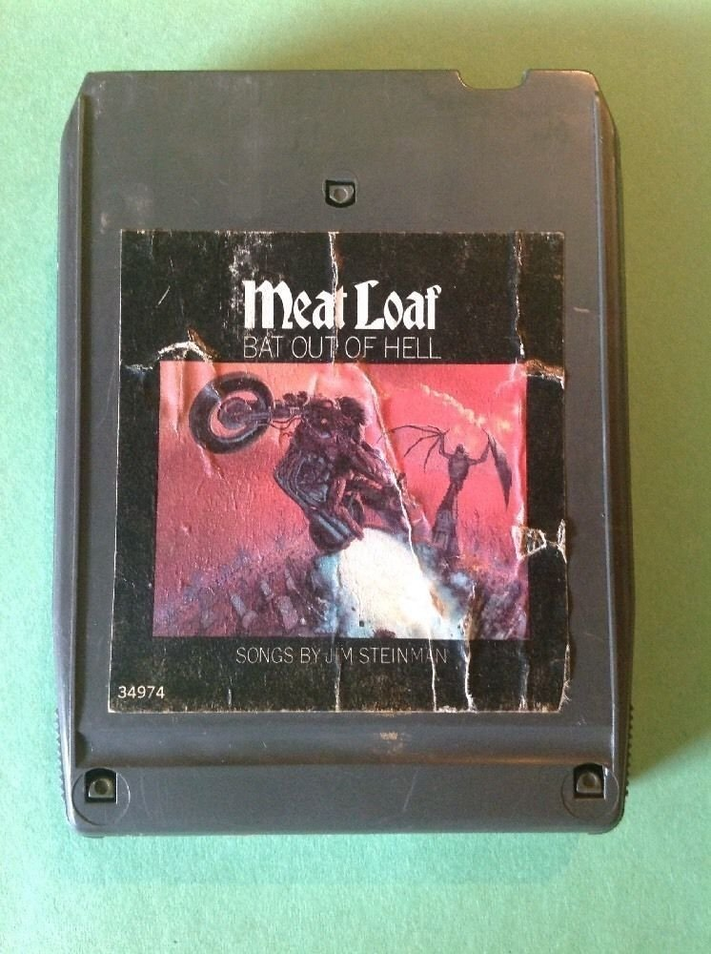

The owner of this 8-track audio tape decided to digitize it to Audio CD in the nineties. Please create a record that encompasses both the 8-track and the Audio CD that was created from it.

Extra credit challenge: if the Audio CD was then digitally ripped to create individual MP3 files for the tracks on this album, how would you add those to the catalog record? (You may use the Internet to look up track titles.)

